Major sources that make up the General Fund total revenue include: Ad Valorem/Property Taxes (35.1%), Sales and Use Tax (2.1%), Franchise Fees (5.1%), Utility Taxes (12.5%), Intergovernmental (6.3%), Charges for Services (9.3%), Licenses & Permits (0.8%), Fines & Forfeitures (1.3%), and Miscellaneous (27.5%).

The five-year estimates for both revenues and expenditures in this section were taken from the financial forecasting model provided by Burton and Associates during the FY 2015 budget cycle. A description of each revenue source as well as a discussion and outlook for next year follows.

**Ad Valorem Taxes**

The proposed ad valorem or property tax millage for operating purposes is 4.1193 and generates $103,148,871, or 35.1% of the General Fund revenue. The tax rate is made up of two components: operating millage rate and voted debt millage rate. A separate debt levy is used to pay debt service costs (principal and interest payments) associated with the City’s outstanding General Obligation Bonds (GOB). Since FY 2012, the revenue collected from the debt millage levy is directly deposited into the Debt Service Fund.

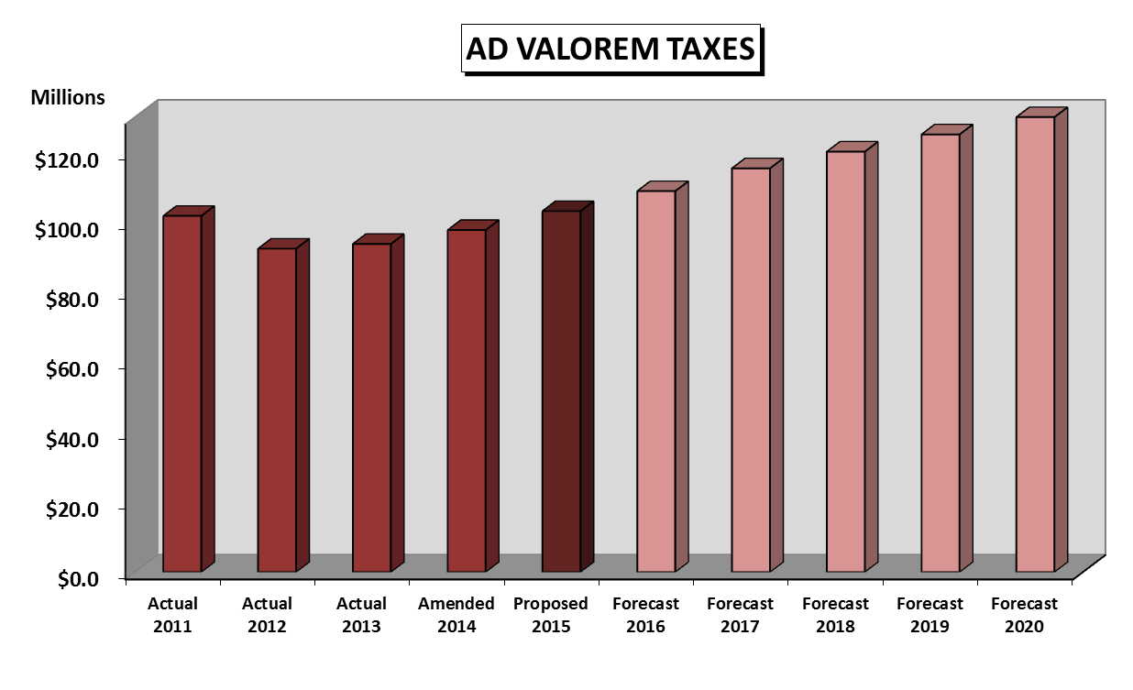

Over the last few years, property taxable values have experienced a slight increase in values as demonstrated in the table above. The City anticipates steady growth over the next few years. For the FY 2015 preliminary tax roll, taxable property values have increased by 6.16%.

The current outstanding General Obligation debt issues include the General Obligation Fire Bond 2005, and the General Obligation Refunding Bonds 2011A and 2011B. The proposed debt service payment for the 2005 Fire Bond Issue is $1,180,841, which requires a levy of $1,183,549 and a millage of 0.0478. The proposed debt service payment for the General Obligation Refunding Bonds 2011A is $1,148,000, which requires a levy of $1,148,394 and proposed millage of 0.0463. The proposed debt service payment for the General Obligation Refunding Bonds 2011B is $2,517,075, which requires a levy of $2,519,435 and proposed millage of 0.1017. The Debt Service levy totals $4,851,378. The City’s combined Debt Service including Special Obligation debt for Pension Obligation Bonds for FY 2015 is $34,629,505. The proposed combined millage for operating and debt service for FY 2015 is 4.3151, which represents a .26% decrease from the 4.3263 FY 2014 combined millage.

**Franchise Fees**

This revenue source consists of payments made by Florida Power and Light (FPL), Peoples Gas, and various sanitation contracts for the privilege of constructing upon, and operating within, the rights-of-way owned by the City. The basis for the fees is provided for in long-term agreements for payment to the City based upon their gross revenue derived from accounts within the City limits, less property tax and minor fees previously paid to the City. Projected FPL and Peoples Gas franchise fees for FY 2015 are $15,025,000, which represents a decrease of 1.3% from the FY 2014 amended budget.

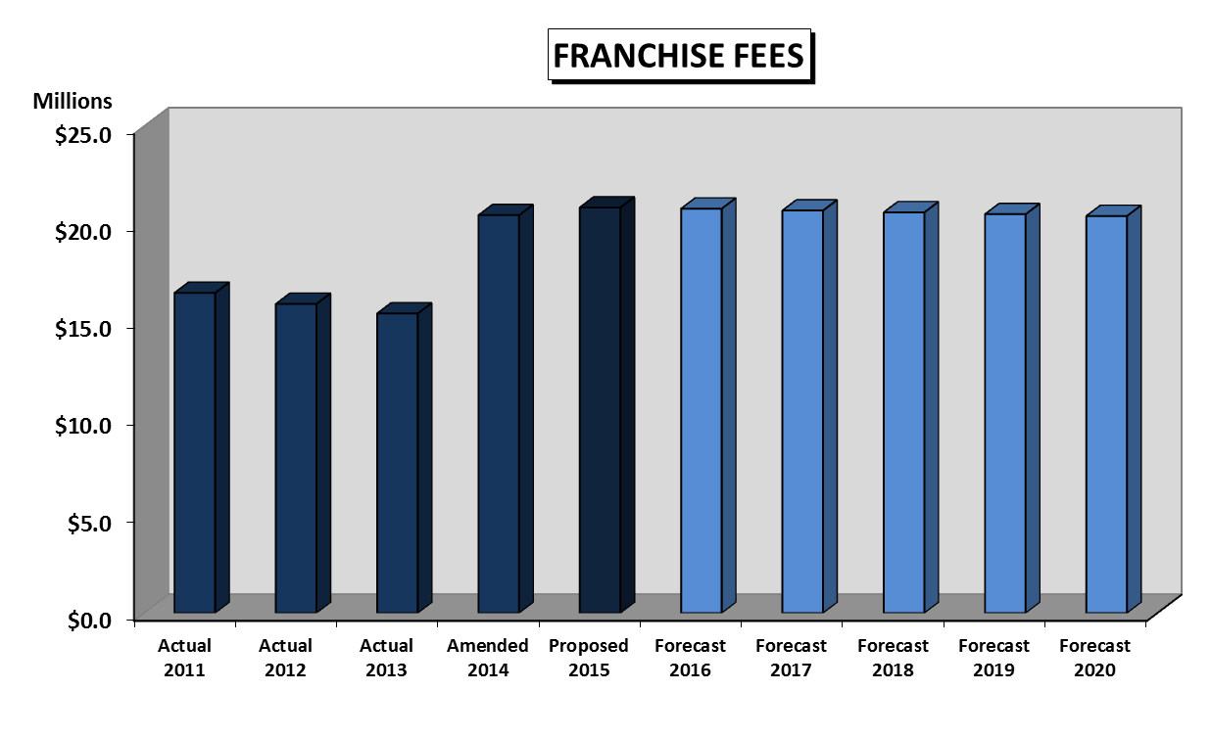

Beginning in FY 2014, sanitation franchise fees are also being deposited into the General Fund. The FY 2014 estimate for Franchise Fees is $5,200,000. Due to contractual changes, it is estimated that the sanitation related franchise collector fees will generate $5,800,000 in FY 2015. The chart above demonstrates this increase in revenue for comparative purposes, however the sanitation franchise fees show up in the charges for services section of the financial schedules.

**Sales & Use Taxes**

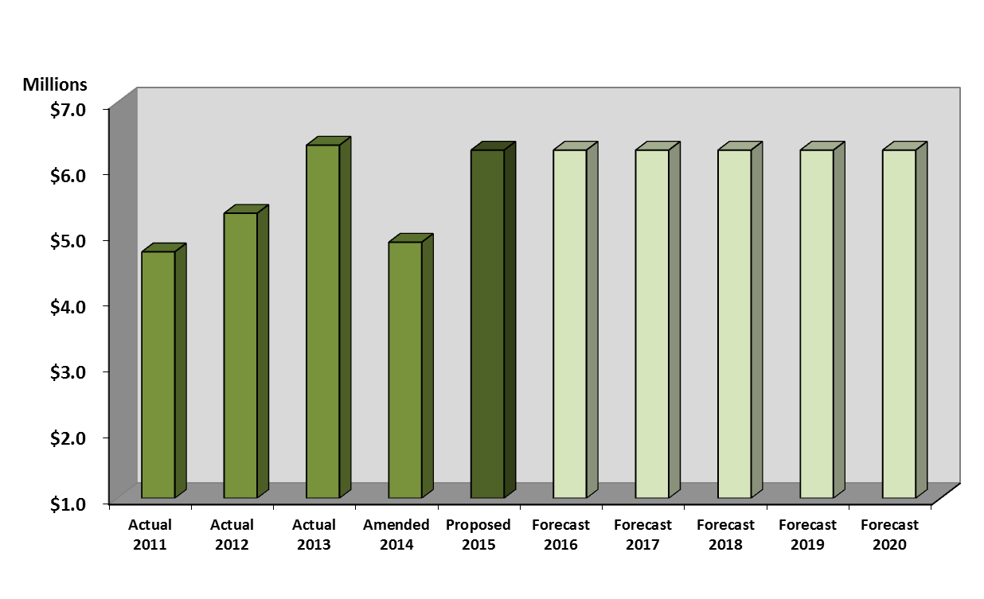Florida Statutes provide for the levy of excise taxes of 1.85% on fire insurance premiums and 0.85% on casualty insurance premiums. These funds are passed through the General Fund as revenue and an expense. Proceeds of these taxes are distributed to eligible municipalities to supplement the Pension and Retirement Trust funds for firefighters and police officers. The proposed revenue for FY 2015 is $6,278,915. It is expected that the FY 2014 actual revenue will also come in higher than the budget. A rate increase is not projected in future years.

**Utility Taxes**

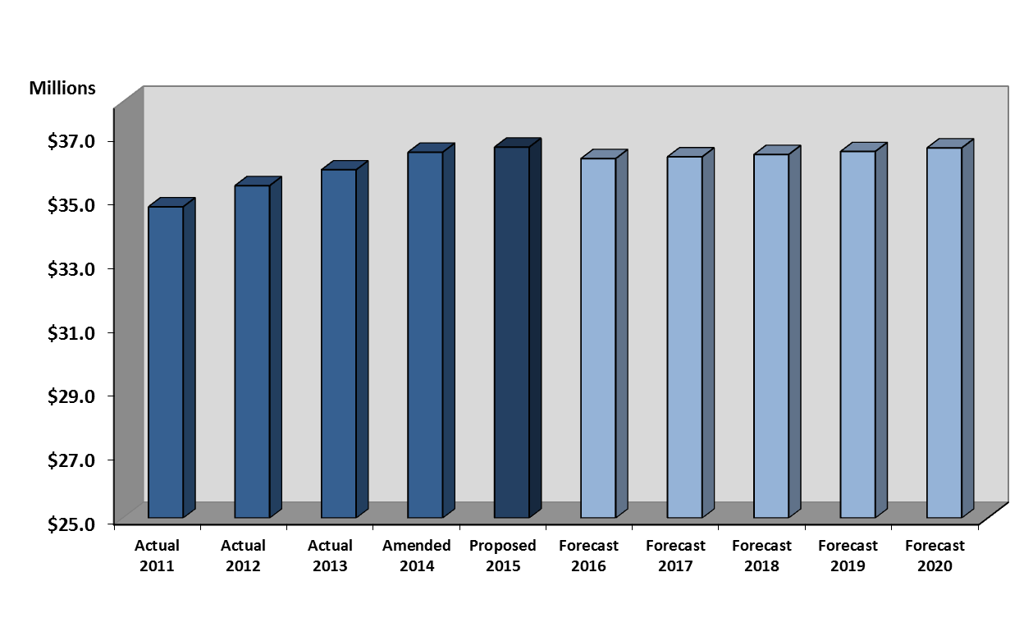This category is comprised of three major components. The largest component is the City utility tax on electricity, charged by FPL to its customers. FPL utility tax is projected to be 51.6% of the proposed FY 2015 utility tax revenues. The second-largest source for this revenue category is the State Communications Services Tax. This tax represents 33.3% of the proposed FY 2015 utility tax revenue, based upon estimates from the Florida Department of Revenue. The third component of utility tax revenue consists of the combination of the City’s utility tax on gas and water utility bills for customers within the City. Water utility taxes increase as water rates and consumption increase. The proposed revenue for FY 2015 is $36,590,101, which represents a .4% increase from the FY 2014 amended budget.

**Charges for Services**

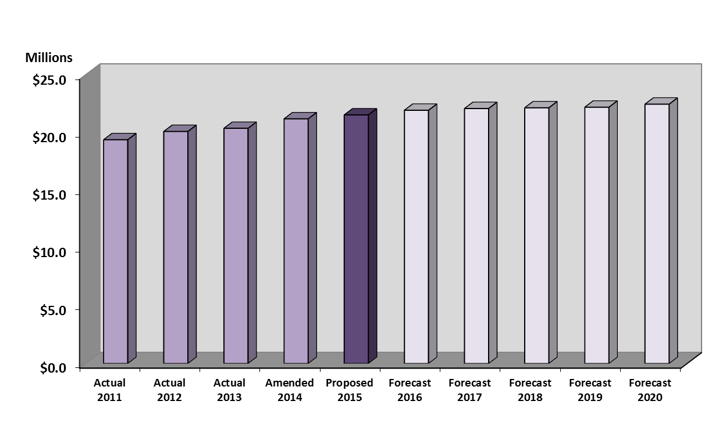This category of revenue is associated with funds received from users of specific services, including fees for fire related inspections, planning, and docks, as well as parks and recreation. The proposed revenue for FY 2015 is $21,527,625, which represents a 1.6% increase from the FY 2014 amended budget.

**Licenses & Permit Fees**

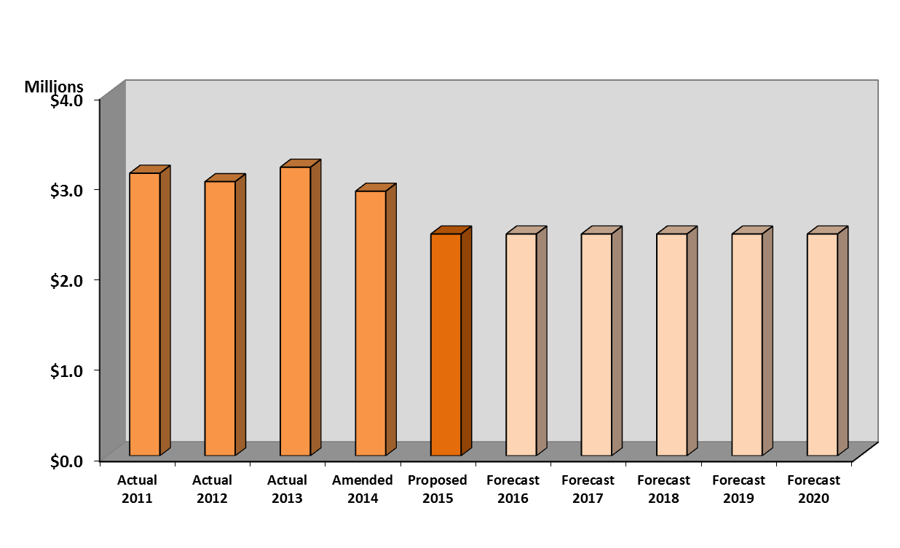This revenue category includes local business tax receipts issued to authorize businesses to operate within the City limits and development permits issued to authorize building and construction within the City limits. The proposed revenue for FY 2015 is $2,451,006, which represents a 16.2% decrease from the FY 2014 amended budget. Fees are projected to remain constant over the next few years.

**Intergovernmental Revenue**

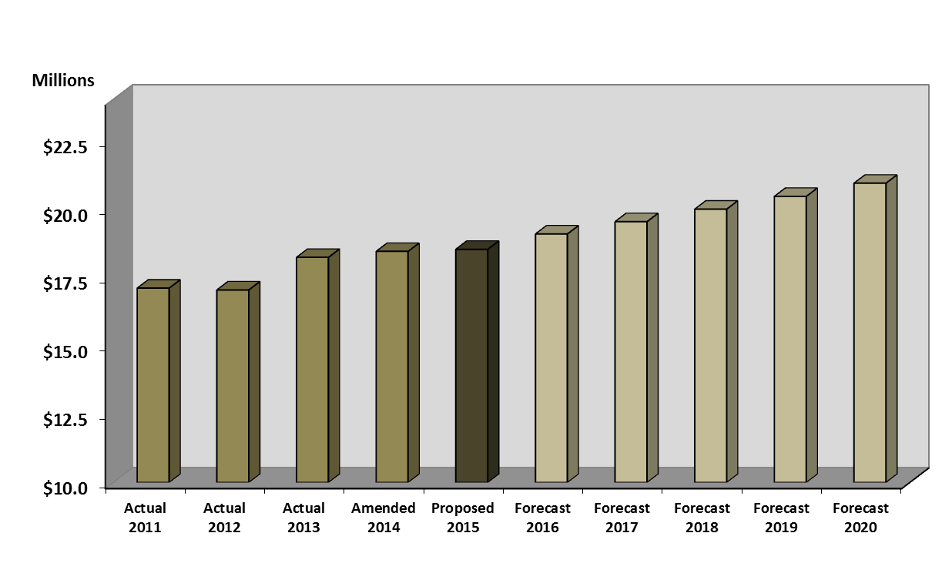This revenue source is recurring State shared and County shared revenue. The State of Florida shares motor fuel, alcoholic beverage license, and sales tax revenue with local governments based on population. Broward County provides gasoline tax and local business tax receipt revenue. The proposed revenue for FY 2015 is $18,518,059, which represents a .4% decrease from the FY 2014 amended budget. A slight increase is projected over the next few years for the shared revenue portions.

**Fines & Forfeitures**

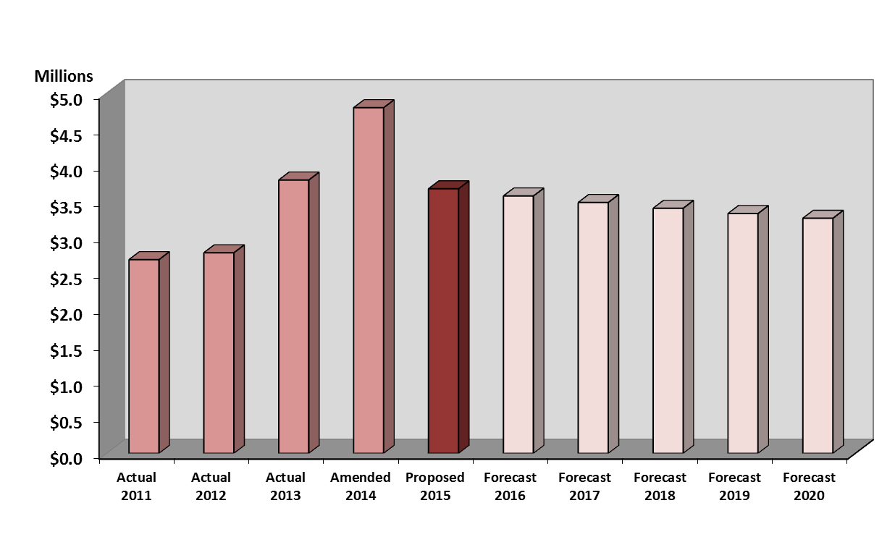This revenue category includes fines for traffic and other violations collected by the County on our behalf through the judicial process. This category represents 1.3% of all General Fund resources. The proposed revenue for FY 2015 is $3,673,829, which represents a 23.5% decrease from the FY 2014 amended budget, primarily due to the citywide reduction in red light camera citations through the Red Light Camera Enforcement Program. The FY 2014 actual revenue is also expected to come in significantly lower than the amended budget as shown.

**Miscellaneous Revenue**

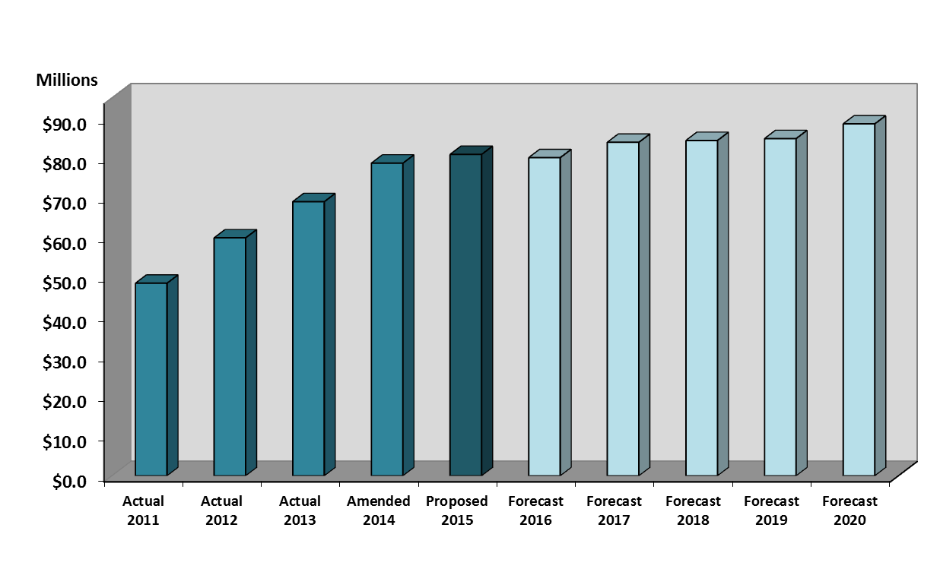This revenue source includes interest earnings, rents, fire assessment fee, return on investments, cost allocation charges, and other direct interfund charges. The fire assessment fee, which appears as a non-ad valorem charge on the tax bill was increased to $225 per residential dwelling in FY 2014. This increase generated approximately $13 million in additional revenue to the General Fund. The proposed miscellaneous revenue for FY 2015 including the Fire Assessment is $80,793,155, which represents an increase of 2.8% from the FY 2014 amended budget.